AWS Bedrock AgentCore Guide
- Install AgentCore Starter Toolkit CLI using pip
  - Enter the following command in the Terminal
pip install bedrock-agentcore-starter-toolkit
Note: Here we are using uv (Python Package Manager) as we are running in VS Studio Code
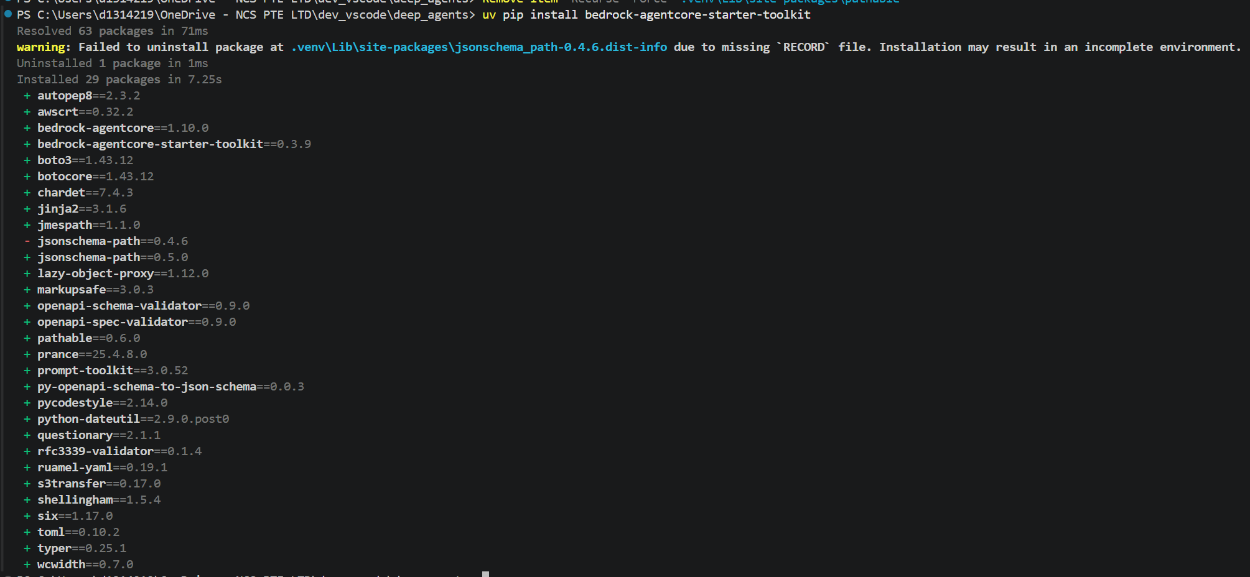
  - Configure your agent
If you get the following error message below, your AWS environment is not configured yet
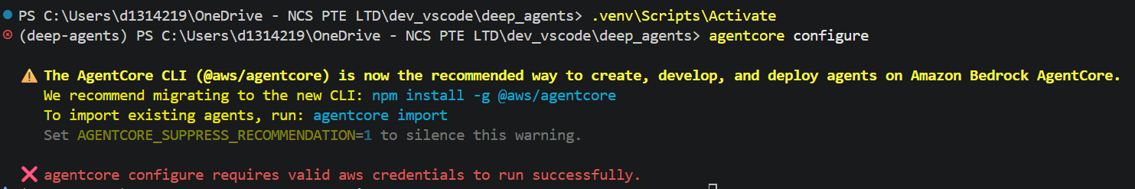

Assuming the aws console has already been installed, run “aws configure” and enter the AWS environment variables from your AWS IAM account as shown below.
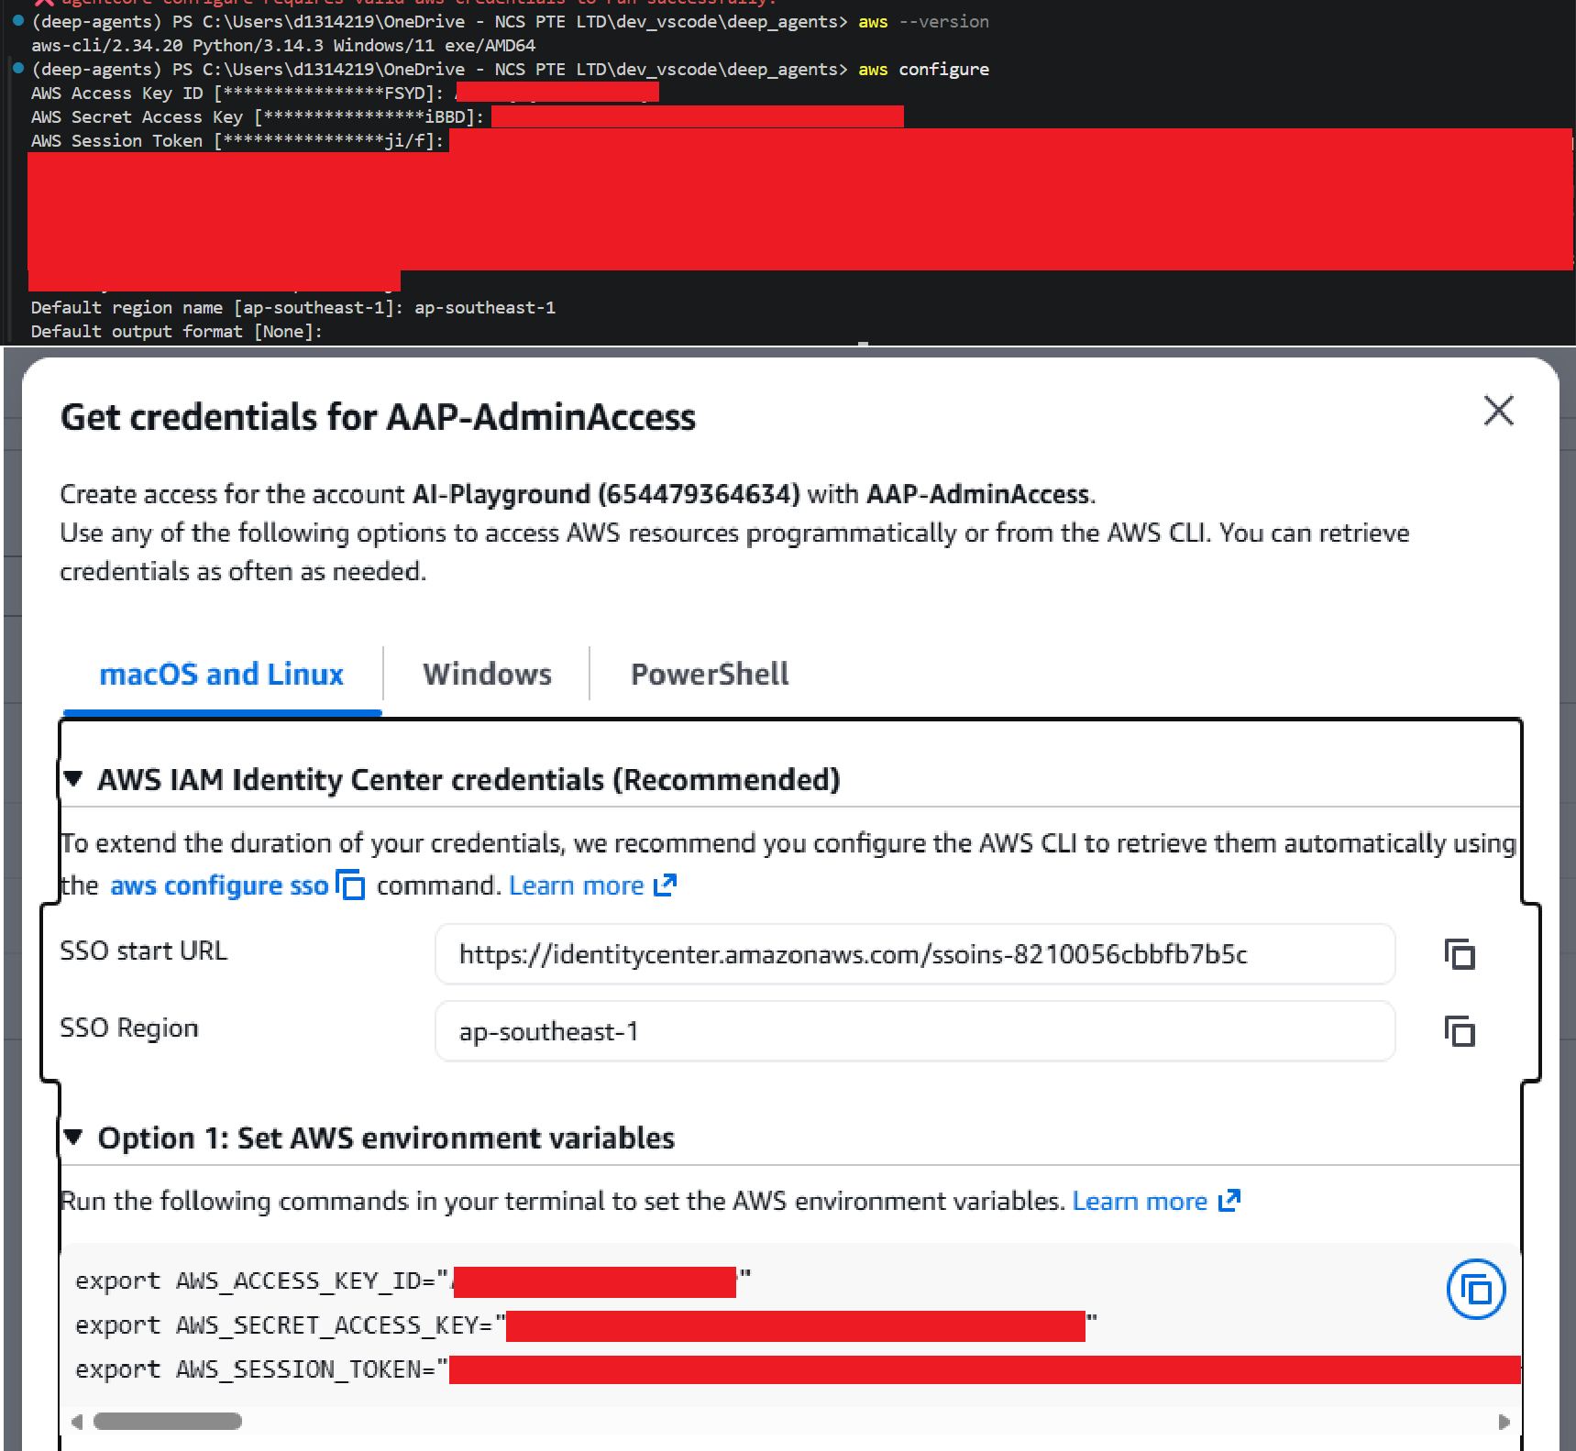
  - Next, run “agentcore configure”

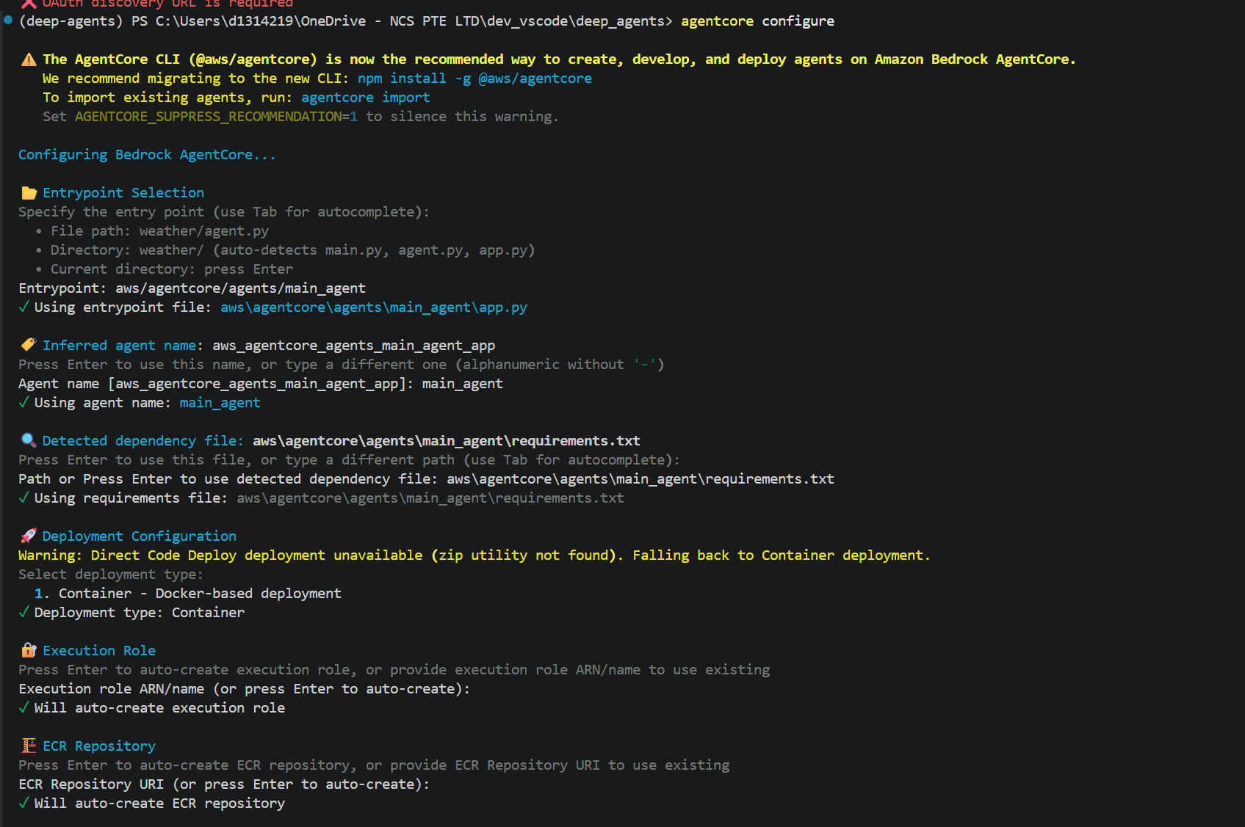
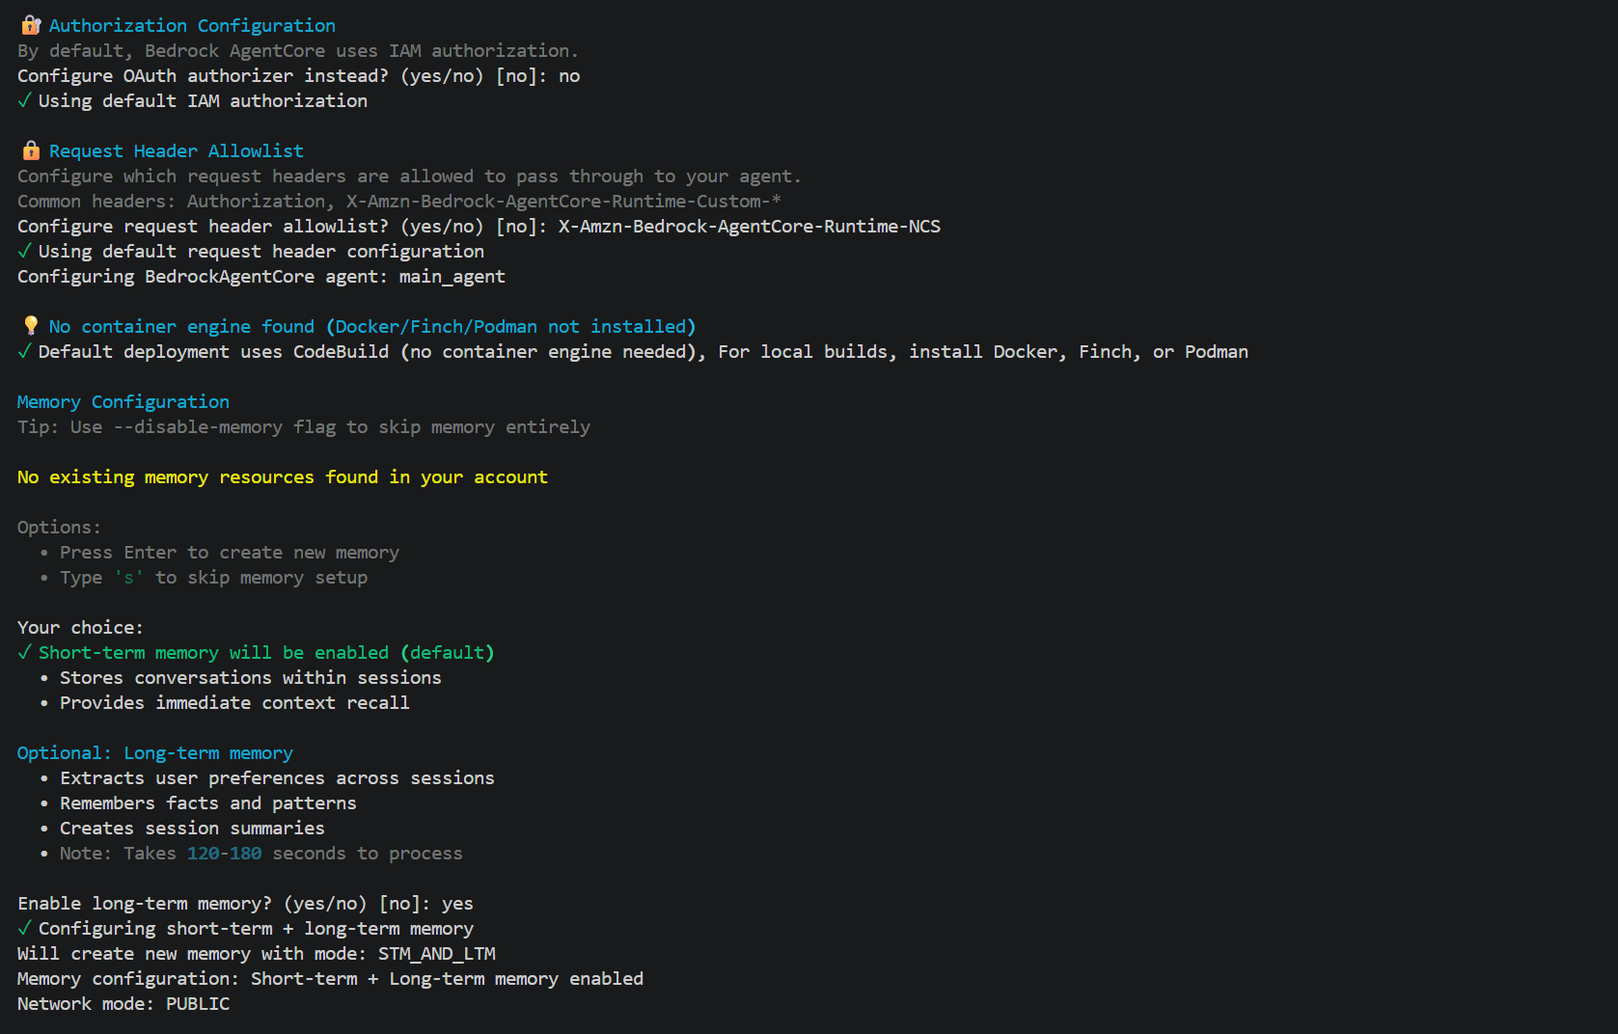
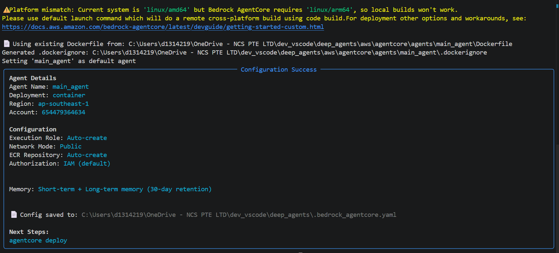

- Awsdasd
- Asd
- asd

